
QUALITY MANAGEMENT SYSTEM
DAN Quality Management System
Design Quality Requirements

Document Control
Document No. | 01-000001-000000-DAN-QMN-SPC-000001 | Revision | R00
Issue Date | June 2026 | Classification | Controlled — Internal
Document Owner | Quality Department | Page Format | US Letter
Approval
Prepared By | Reviewed By | Approved By
Quality Manager  Signature / Date | Amjed Sammari  Delivery Director  Signature / Date | AbdulHalim Kaissy  Chief Development Officer (CDO)  Signature / Date

Table of Contents

Document Control — Review and Approval
Purpose
1. Overview and Scope
2. Employer's Requirements (ER)
2.1 Scope
2.2 Node Programme
2.3 Amenity Inclusion
2.4 Theming and Design Intent
2.5 Design Standards
3. Roles and Responsibilities
3.1 RACI Matrix
4. Inputs Required for Design
5. Design Process
6. Design Process Quality Control
7. Design Documents Control
8. Templates
Attachments and Templates
A1 — Design Review Process Map
Revision History

Document Control — Review and Approval
These Design Quality Requirements are a Quality Function document, prepared, reviewed and approved by the relevant quality personnel.
Action | Name | Role | Date
Prepared by | Quality Manager | Quality Department | June 2026
Reviewed by | Amjed Sammari | Delivery Director | June 2026
Approved by | AbdulHalim Kaissy | Chief Development Officer (CDO) | June 2026
Amendment History
Version | Date | Details
R00 | June 2026 | First issue — DAN Design Quality Requirements, aligned to ISO 9001:2015 and the Client Quality Management Review requirements, including the Employer's Requirements (ER), a RACI matrix and the Design Review Process Map.

Purpose
This document defines DAN's design quality requirements — the processes and controls that ensure design output meets DAN's quality standards, the Employer's Requirements (ER) and applicable codes. It applies to all design and development undertaken for DAN projects, whether by DAN's in-house design function or by appointed design consultants, and is issued under the DAN Quality Management Manual (01-000001-000000-DAN-QMN-MAN-000001).
Note: This document is issued in DAN's standard quality-management format, consistent with the DAN Quality Management Manual (QMM).

1. Overview and Scope
These Design Quality Requirements establish the framework for planning, controlling and verifying design so that outputs are compliant, coordinated and fit for purpose.
- Purpose — to define the requirements for the development and control of design quality across all project phases and disciplines.
- Project information — project description, scope of work and design-team composition are recorded at project mobilisation.
- Design activities and interfaces — the design activities, and the interfaces between organisational functions and groups managed by this document, are identified and controlled.

2. Employer's Requirements (ER)
The Employer's Requirements (ER) is DAN's formal statement of what the design must deliver. It is issued to the design team as a controlled design input and forms the basis for design verification and acceptance.

2.1 Scope
Defines the development scope, the project boundaries and the deliverables expected from design, procurement and construction. [Project-specific scope statement]

2.2 Node Programme
Defines the development nodes / plots, their uses, phasing and the design programme milestones for each node. [Project-specific node programme and schedule]

2.3 Amenity Inclusion
Defines the amenities to be provided (e.g. community, retail, recreation, landscape and public-realm elements) and their standards of provision. [Project-specific amenity schedule]

2.4 Theming and Design Intent
Defines the theming, character and design intent — the look, feel and identity the design must achieve, and the quality of finishes and experience expected. [Project-specific theming and design-intent statement]

2.5 Design Standards
Defines the codes, standards, specifications and performance requirements the design must satisfy:
- Saudi Building Code (SBC) and applicable municipal / authority requirements.
- Referenced international design standards for each discipline (civil, structural, architectural, MEP, infrastructure).
- Sustainability / green-building requirements and environmental standards applicable to the project.
- DAN specifications and material / workmanship standards. [Any additional project-specific standards]

3. Roles and Responsibilities
Roles are defined for project management, production / engineering management and the quality manager, together with the design consultant and DAN as Employer.
- Project Management — plans and controls the design programme, budget and interfaces; issues the ER.
- Production / Engineering Management — leads design development and technical delivery by discipline.
- Quality Manager — owns these Design Quality Requirements; sets design QA/QC controls; conducts design-quality audits and verifies compliance.
- Design Consultant / Designer — produces the design to the ER and standards; performs internal checks; raises design changes and RFIs.
- Employer (DAN) — issues the ER; reviews and approves design at stage gates.

3.1 RACI Matrix
Responsibility for each design-quality activity is assigned as R (Responsible), A (Accountable), C (Consulted) or I (Informed):
Activity | PM | Eng. Mgr | Quality Mgr | Designer | Employer
Issue Employer's Requirements (ER) | R | C | C | I | A
Validate design inputs / requirements review | A | R | C | C | I
Design development (by discipline) | C | A | C | R | I
Interdisciplinary coordination | A | R | C | R | I
Internal design review (QA/QC) | I | C | A | R | I
Design verification against ER & standards | C | C | A | R | I
Design change management | A | R | C | R | I
Stage-gate design approval | C | C | C | I | A
Design records and document control | I | C | A | R | I

4. Inputs Required for Design
Design inputs are validated and a requirements review is performed before design proceeds. As part of the requirement-statement submission, receipt of the following is verified:
- Output requirements (features, functions) and the purpose of the project.
- Delivery timeline and the assumptions required to progress design.
- Opportunities, constraints and risk analysis.
- Regulatory and compliance requirements.
- Budget / cost constraints, funding limits or cost targets.
- Design history or lessons learned, and the change-control process.

5. Design Process
- Design requirement statement and interdisciplinary interface management.
- Software used in design activities and the design-management procedures.
- Change-management process and design-output validation process.
- Design risk-assessment matrix and the key-stakeholder communication plan.
- Integration of environmental-impact assessments and validation of compliance with green standards.
- Internal or external compliance audits and regulatory reviews.
- Post-design activities — maintenance, product-lifecycle management and lessons learned.

6. Design Process Quality Control
- Quality Policy, signed by the project manager, with identified quality objectives and KPIs.
- Risk-management plan and internal-audit programme.
- Project management review and internal review procedures.
- Processes for monitoring, measurement, analysis and improvement.
- Compilation of lessons learned from the project.

7. Design Documents Control
- All design documents are version-controlled and incorporate change tracking.
- A formal approval and sign-off process by all key stakeholders is established.
- Templates and formats ensure consistency across all documentation.
- Design documents are cross-referenced to maintain consistency and avoid conflicts.
- Records of reviews and checks are maintained for audit purposes.
- Documents generated by the design process (methods, assumptions, formulas) are managed and retained.

8. Templates
The following controlled templates support these Design Quality Requirements:
- Design Change Request.
- Design Change Request Log.
- Requirements Review Checklist.

Attachments and Templates
The following attachments form part of these Design Quality Requirements:
Ref | Attachment
A1 | Design Review Process Map (below)
A2 | Design Change Request
A3 | Design Change Request Log
A4 | Requirements Review Checklist

A1 — Design Review Process Map
The stage-gate design review process, from the Employer's Requirements through internal QA/QC review and verification to stage-gate approval and controlled issue:
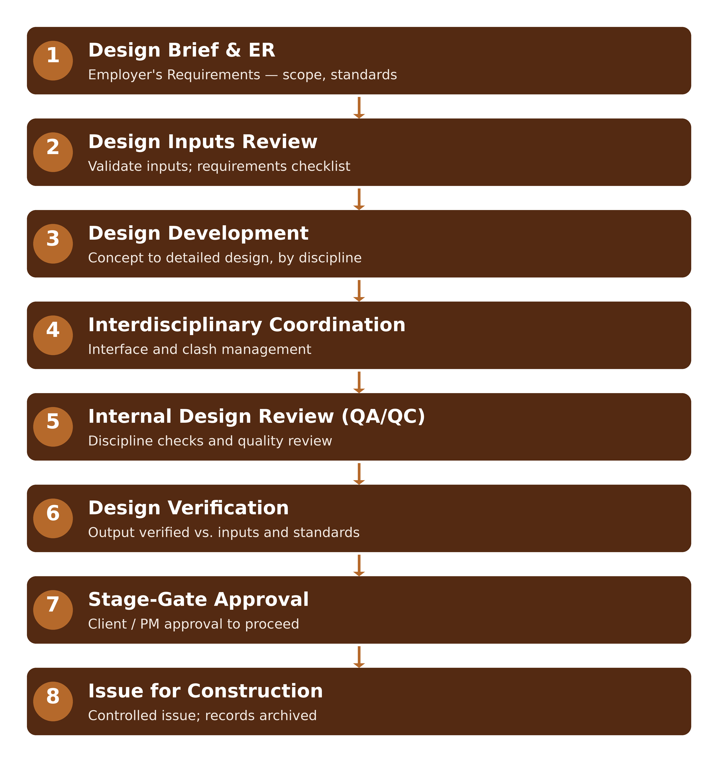
Attachment A1 — Design Review Process Map

Revision History
Rev. | Date | Description of Change | Approved By
R00 | June 2026 | First issue — DAN Design Quality Requirements, aligned to ISO 9001:2015 and the Client Quality Management Review requirements, including the Employer's Requirements, a RACI matrix and the Design Review Process Map. | Delivery Director

